Launch one aws ec2 and install jenkins.
First need to lunch aws server by ec2 services and login to server by using command of (ssh -I privatekey.pem ec2-user@publicip) and once its been connected need to go for root (sudo -i) and need to check java is been installed or not if not use the command to install java(yum install openjdk.version.jdk -y) and once it get install use the command to install the Jenkins(yum install Jenkins)and use the command to start (systemctl start Jenkins) and check the status (systemctl status Jenkins) check in the browser while using public ip with port no 8080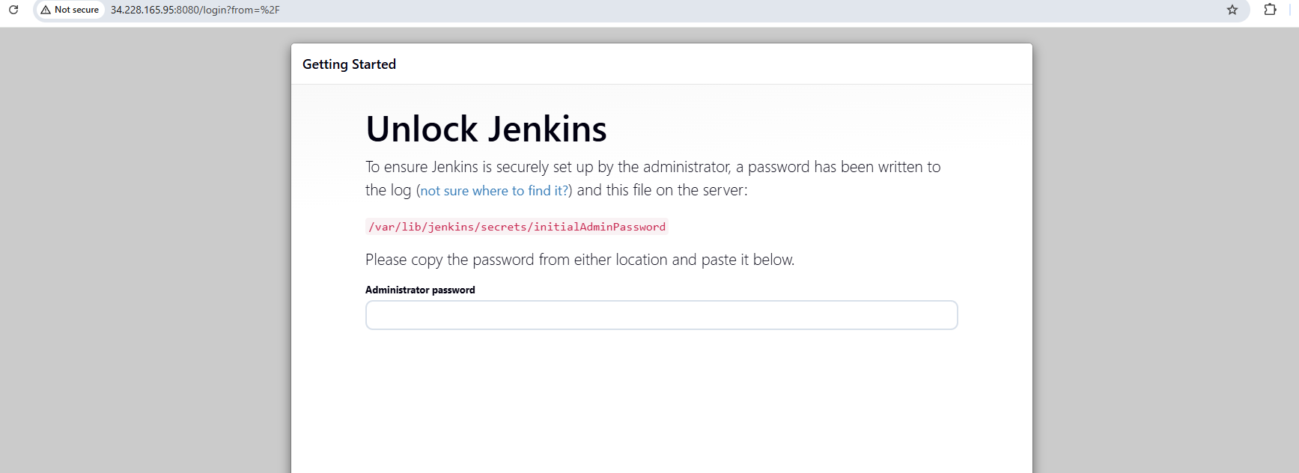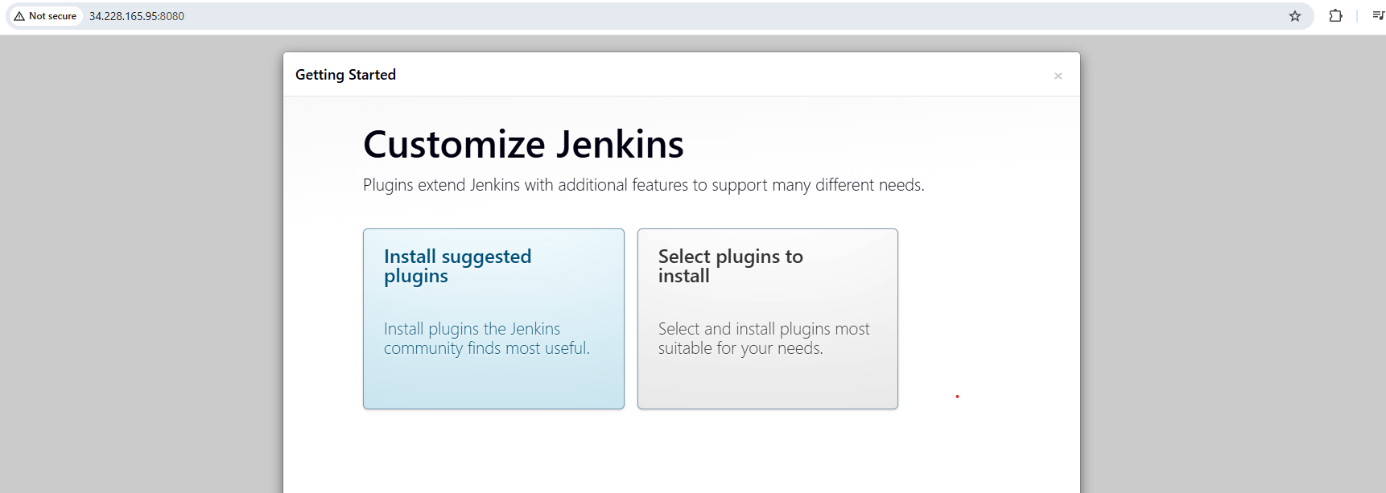
2. Setup Apache Tomcat on Ubuntu Virtual Machine
To able to setup the tomcat on ubuntu first need to install java or update the java once it get update visit to tomcat site need to copy the tar link of profile and open the ubuntu and use command to download the file (wget paste link ) and once it get downloaded extract the file and change the permission to execute and change the directlry visit to bin and use the command to start the file (./startup.sh) check in browser with port no :8080 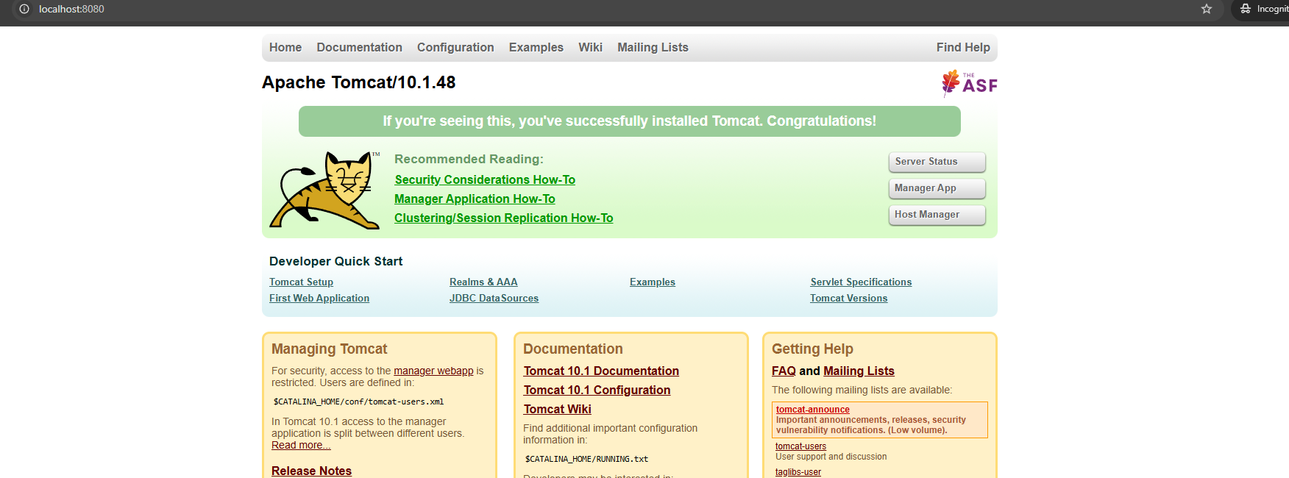

- Setup Docker Desktop on your local windows.
Ans : first need to open the power shell and need to run this command (dism.exe /online /enable-feature /featurename:Microsoft-Windows-Subsystem-Linux /all /norestart) (dism.exe /online /enable-feature /featurename:VirtualMachinePlatform /all /norestart) then need to restart the system and then need to visit docker site and select for the windows and install and setup 